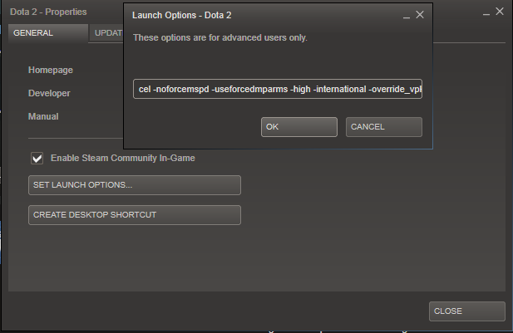

CREATE DESKTOP SHORT 0'